Debriefing A Long Walk to Water: A Lesson in 3 Moments
By Marie Himes

Learning Objectives:
- Identify and analyze themes present in A Long Walk to Water
- Analyze how the author characterizes Nya and Salva using text structures, style, and literary devices
- Compare and contrast Salva’s and Nya’s perspectives on a common theme

Preparing Learners
(5 minutes) Anticipatory Guide (w/Dyad Share) – Themes from A Long Walk to Water

(5 minutes + 2-minute debrief) Save the Last Word for Me – This discussion strategy requires all students to participate as both active speakers and active listeners. Working in groups of four, students follow a pattern of sharing and discussing their responses to a text, image, or question. By creating a clear structure for the discussion, this strategy encourages reserved students to share their ideas and ensures that frequent speakers practice being quiet. For this particular discussion, student A will choose an image and respond to question 1: What is shown in the picture or photo? Then students B, C, D, and finally A will respond to question 2 based on the same image: How does it connect to Salva’s or Nya’s narrative in A Long Walk to Water? The discussion continues with student B choosing an image, responding to question 1, and then students C, D, A, and B responding to question 2. Repeat this process until all students have gotten to describe an image (question 1) or time is up.

Interacting with Text/Concept
Text
A Long Walk to Water by Linda Sue Park

(15 minutes) Reading Aloud in Four Voices Jigsaw (w/FAST Characterization Graphic Organizer) –
Excerpt A: Nya – Chapter 1, Page 1
Excerpt B: Nya – Chapter 7, Page 39
Excerpt C: Salva – Chapter 1, Page 1-2
Excerpt D: Salva – Chapter 7, Page 41

Extending Understanding
(10 minutes) Two-Voice Poem – A Two-Voice Poem is a way for an author to juxtapose characters. These poems are written from two different people’s points of view on the same theme. With a partner, agree on a theme that connects Nya’s and Salva’s narratives, and then write a two-voice poem from the perspectives of Nya and Salva.

A Long Walk to Water:
Anticipatory Guide

 | Opinion |  | Reasoning:  Explain Using Your Own Words
 | Agree | Disagree
1. Man is basically good.
2. Government’s most important job is to protect its people.
3. War is a necessary evil.
4. Character is born of adversity.
5. Man must care for himself first before he can help others.
6. Water is our most precious resource.

Dyad Share
Formulaic Expressions
S1: I will read statement 1. It says _______________. I agree/disagree with it because __________. So I am going to mark it agree/disagree. What do you think?

S2: I agree/disagree with you because _____________. So for statement 1, I will mark agree/disagree. Now let me read statement 2. It says _____________. I agree/disagree…

Save the Last Word for Me:
What is shown in the picture or photo? How does it relate to Salva’s or Nya’s narratives in A Long Walk to Water?
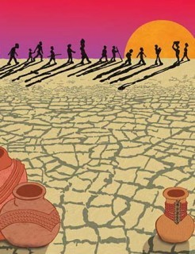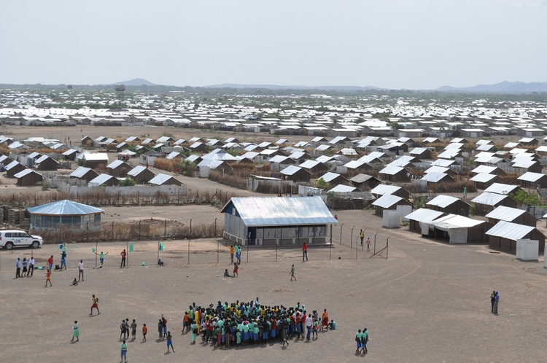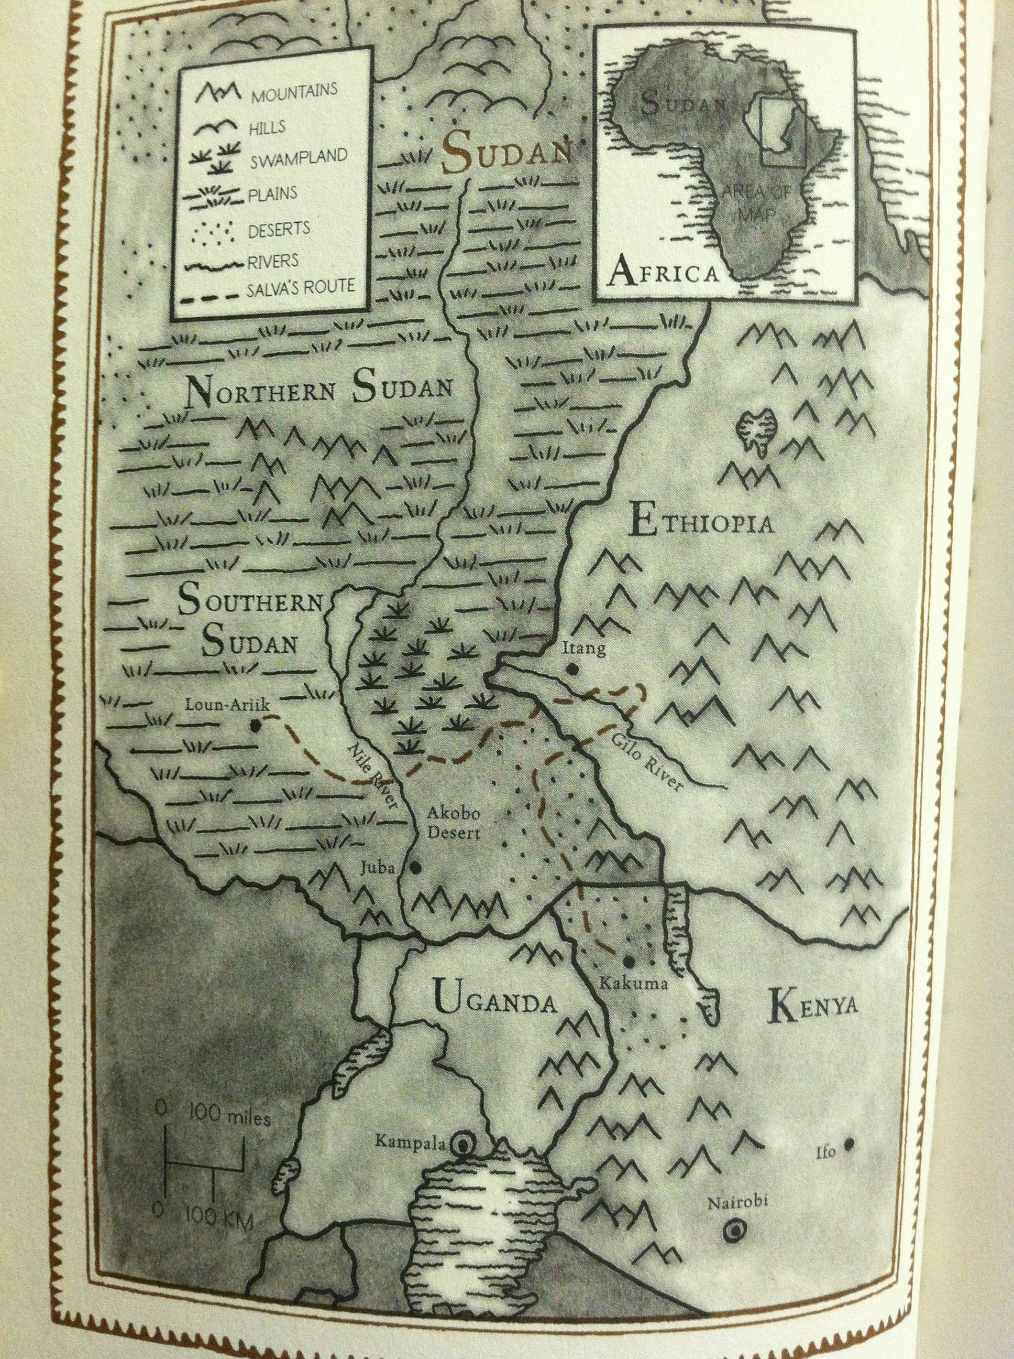

Reading Aloud in Four Voices:
A Long Walk to Water by Linda Sue Park

Excerpt A from Nya’s Narrative (Chapter 1, page 1)
Going was easy.
Going, the big plastic container held only air. Tall for her eleven years, Nya could switch the handle from one hand to the other, swing the container by her side, or cradle it in both arms. She could even drag it behind her, bumping it against the ground and raising a tiny cloud of dust with each step.
There was little weight, going. There was only heat, the sun already baking the air, even though it was long before noon. It would take her half the morning if she didn’t stop on the way.
Heat. Time. And Thorns.

Excerpt B from Nya’s Narrative (Chapter 7, page 39)
Nya sat on the floor. She reached out and took her little sister’s hand.
Akeer did not seem to notice. She lay curled on her side, hardly moving, silent except for an occasional whimper.
Her silence frightened Nya. Only two days earlier, Akeer had complained noisily and at length about the pains in her stomach. Nya had been annoyed by all the whining. Now she felt guilty, for she could see that her sister no longer had enough strength to complain.

Excerpt C from Salva’s Narrative (Chapter 1, page 1-2)
Salva sat cross-legged on the bench. He kept his head turned toward the front, hands folded, back perfectly straight. Everything about him was paying attention to the teacher—everything except his eyes and his mind.
His eyes kept flicking toward the window, through which he could see the road. The road home. Just a little while longer—a few minutes more—and he would be walking on that road.

Excerpt D from Salva’s Narrative (Chapter 7, page 41)
Listening to Uncle, hurrying to stay close to him, Salva was able to make his feet move despite the cold terror throughout his whole body.
But nothing was all right. He had lost his family, and now he had lost his friend as well.
No one had heard any screaming in the night. Salva hoped with all his heart that the lion had killed Marial instantly—that his friend hadn’t had time to feel fear or pain.

FAST Characterization Graphic Organizer:
Cite 1-2 pieces of evidence from the text that show important character traits expressed through what Nya and Salva Feel, do (Actions), Say, and Think (FAST).
Character | Excerpt | FAST Characterization
Nya | Chapter 1, page 1 | FEELINGS
 |  | ACTIONS
 |  | SAYS
 |  | THOUGHTS
 | Chapter 7, page 39 | FEELINGS
 |  | ACTIONS
 |  | SAYS
 |  | THOUGHTS
Salva | Chapter 1, page 1-2 | FEELINGS
 |  | ACTIONS
 |  | SAYS
 |  | THOUGHTS
 | Chapter 7, page 41 | FEELINGS
 |  | ACTIONS
 |  | SAYS
 |  | THOUGHTS
Two-Voice Poem:
A Two-Voice Poem is a way for an author to juxtapose characters. These poems are written from two different people’s points of view on the same theme. Below is a sample two-voice poem on the theme “opposites attract,” written from the viewpoints of Batman and the Joker.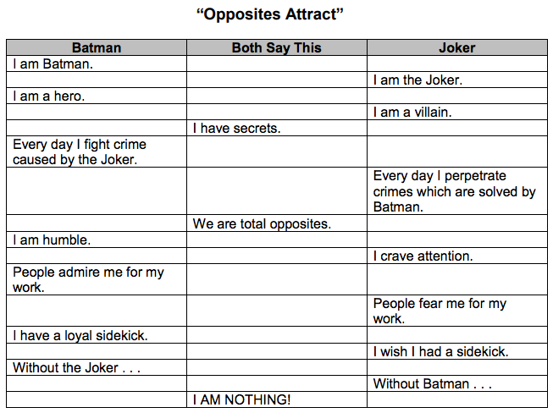
The author is juxtaposing Batman and the Joker by putting them on opposite sides of the same theme. We first hear from Batman and then the Joker, and their voices alternate as we read through the poem. Notice that, even though these two people are very different, there are some things that they have in common: “I have secrets”; “We are total opposites”; “I am nothing”. If these two characters were reading the poem, they would say the things they have in common at the same time.

Now you are going to write your own two-voice poem using Salva and Nya as the voices.

Your Task: Write a text-based two-voice poem spoken by Nya and Salva that expresses how these characters survived in challenging environments. Your poem must use details from the narratives in A Long Walk to Water and reflect an interwoven theme from the book. Possible themes include 1) perseverance is necessary to survive; 2) survival requires physical strength; 3) survival requires emotional strength; 4) people must help each other in order to survive; 5) a strong family is a survival advantage; and 6) write your own theme (must be approved by teacher).

Name: ______________________________ Date: ________________

Two-Voice Poem: Salva and Nya from A Long Walk to Water

Theme: ____________________________________________________________________

Salva | Both Say This | Nya

Two-Voice Poem Grading Checklist: Your Poem . . .
1) Is written about a common theme ______
2) Explains at least one way Salva survived a challenge ______
3) Explains at least one way Nya survived a challenge ______
4) Includes a quote from story on Salva’s side ______
• Quote is written, punctuated, and cited correctly ______
5) Includes a quote from story on Nya’s side ______
• Quote is written, punctuated, and cited correctly ______
6) Includes at least three things that both characters say ______

